A000-Asia-Indus-Rhyton-Bull-2000 BCE

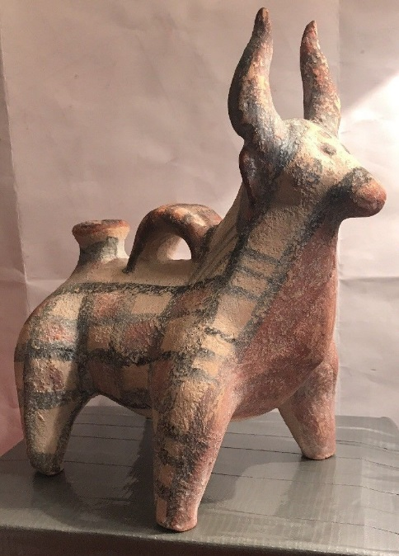 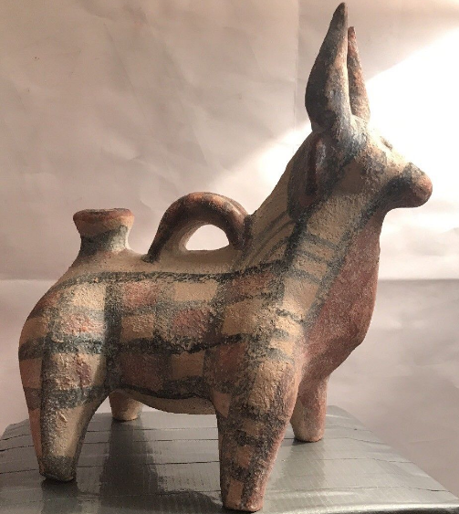 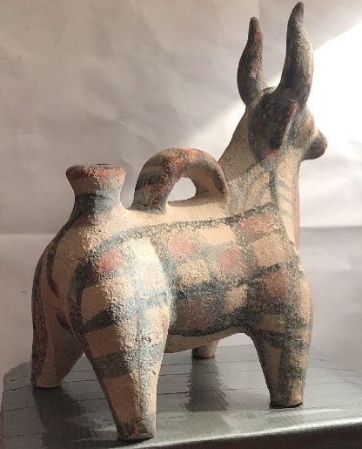

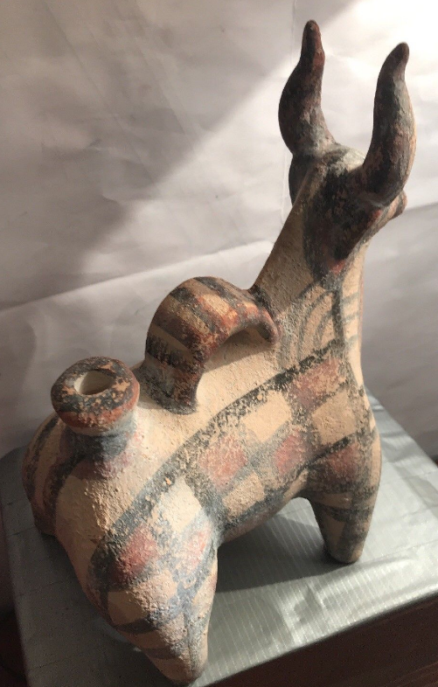 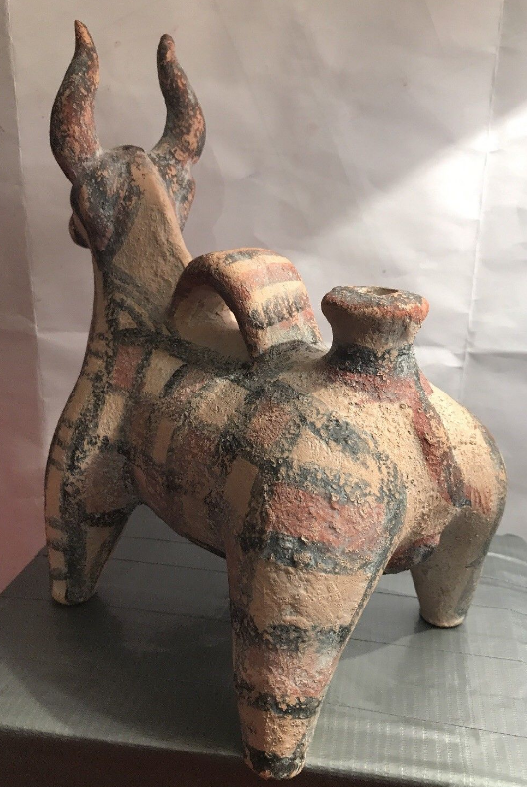 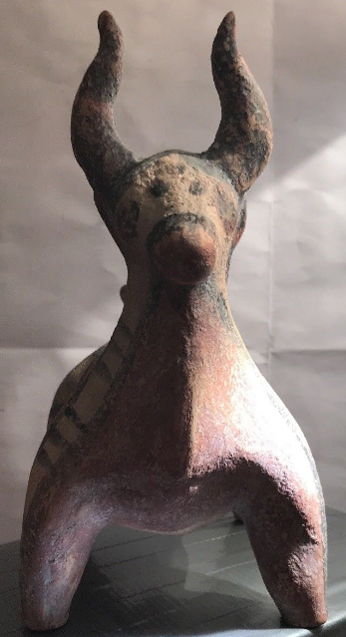

**Case No.: 3**

**Accession No.**

**Formal Label:** Asia-Indus-Rhyton-Bull-2000 BCE

**Display Description: This is a very rare rhyton from the Indus valley c 2000 BCE suggests connections with Mesopotamian civilizations that also engaged in fashioning rhyta for ritual libation purposes at this time horizon. This example displays the traditional rhyton handle affixed to the dorsal part of the bull with the libation spout directly anterior to it. Distinctive rectilinear markings along with red painted interiors of some rectangles suggests a tribal identity.**

**Accession Number:**

**LC Classification:**

**Date or Time Horizon:**

**Geographical Area:**

**Map:**

**GPS coordinates:**

**Cultural Affiliation:**

**Media:**

**Dimensions:**

**Weight:**

**Condition:**

**Provenance:**

**Discussion:**

**References:**